**Question 1**

**Question 2**

1. X = np.vstack((X_circ, X_line)) #All points

2.

3.

4. # Item 2: Total least squares line fitting with scicpy.optimize with RANSAC

5. import math

6. from scipy.optimize import minimize

7. N = X_line.shape[0] # points

8. X_ = X_line

9.

10. def line_equation_from_points(x1, y1, x2, y2):

11. # Calculate the direction vector (Δx, Δy)

12. delta_x = x2 - x1

13. delta_y = y2 - y1

14.

15. # Calculate the normalized vector (a, b)

16. magnitude = math.sqrt(delta_x**2 + delta_y**2)

17. a = delta_y / magnitude

18. b = -delta_x / magnitude

19.

20. # Calculate d

21. d = (a * x1) + (b * y1)

22.

23. # Return the line equation in the form ax + by = d

24. return a, b, d

25.

26. # RANSAC to fit a line

27. # returning the error

28. def line_tls(x, indices):

29. a, b, d = x[0], x[1], x[2]

30. return np.sum(np.square(a*X_[indices,0] + b*X_[indices,1] - d))

31.

32.

33. # Constraint

34. # x = [a,b]

35. def g(x):

36. return x[0]**2 + x[1]**2 - 1

37.

38. # maintaining a**2 + b**2 = 1

39. cons = ({'type': 'eq', 'fun': g})

40.

41. # Computing the consensus (inliers)

42. def consensus_line(X_, x, t):

43. a, b, d = x[0], x[1], x[2]

44. error = np.absolute(a*X_[:,0] + b*X_[:,1] - d)

45. return error < t

46.

47.

48. t = 1. # Threshold value to determine data points that are fit well by model.

49. d = 0.84*N # Number of close data points required to assert that a model fits well to data.

50. s = 2 # Minimum number of data points required to estimate model parameters.

51.

52. inliers_line = [] # Indinces of the inliers

53. max_iterations = 5000

54. iteration = 0

55. best_model_line = [] # Best model normal (a, b) and distance from origin d

56. best_error = np.inf

57. best_sample_line = [] # Three-point sample leading to the best model computation

58. res_only_with_sample = [] # Result (a, b, d) only using the best sample

59. best_inliers_line = [] # Inliers of the model computed form the best sample

60. x0 = np.array([1, 1, 0]) # Initial estimate a,b,d

61.

62. while (iteration < max_iterations):

63. indices = np.random.randint(0, N, s) # A sample of 2 points selected at random

64.

65. #return many things but res.x contains a,b,d

66. res = minimize(fun = line_tls, args = indices, x0 = x0, tol= 1e-6, constraints=cons, options={'disp': False})

67.

68. #returns indexes of cordinates of inliners

69. inliers_line = consensus_line(X_, res.x, t) # Computing the inliers

70.

71. # print('rex.x: ', res.x)

72. # print('Iteration = ', iteration, '. No. inliners = ', inliers_line.sum()) # number of inliners

73.

74. if np.sum(inliers_line) > d:

75. x0 = res.x

76. print('no of inliners = ',np.sum(inliers_line), d)

77. # Computing the new model using the inliers

78. #return many things but res.x contains a,b,d

79. res = minimize(fun = line_tls, args = inliers_line, x0 = x0, tol= 1e-6, constraints=cons, options={'disp': False})

80.

81. #print(res.x, res.fun) # what is fun

82. if res.fun < best_error:

83. # print('A better model found ... ', res.fun, best_error)

84. best_model_line = res.x

85. best_error = res.fun

86. best_sample_line = X_[indices,:]

87. # res_only_with_sample = x0

88. best_inliers_line = inliers_line

89.

90. iteration += 1

91.

92.

93. print('Best line model', best_model_line)

94.

Code for RANSAC circle

1. new_xline = X_line[~best_inliers_line]

2. new_X = np.vstack((X_circ, new_xline)) #All points

3.

4. import math

5. import numpy as np

6. from scipy.optimize import minimize

7. N = new_X.shape[0] # points

8. # X_ = new_X

9.

10. def circle_tls(x, indices):

11. x0, y0, r = x[0], x[1], x[2]

12. datapoints = new_X[indices]

13. squared_distances = np.sum((datapoints - np.array([x0, y0]))**2, axis=1)

14. error = np.abs(squared_distances - r**2)

15. return np.sum(error)

16.

17. def consensus_circle(new_X, x, t):

18. xc, yc, r = x[0], x[1], x[2]

19. point_to_center = np.sqrt(np.square(new_X[:,0] - xc) + np.square(new_X[:,1] - yc))

20. return (point_to_center < r+t) & (point_to_center > r-t)

21.

22. t = 1.0 # Threshold value to determine data points that are fit well by model.

23. # increase d to 0.8N

24. d = 0.85*N # Number of close data points required to assert that a model fits well to data.

25. s = 3 # Minimum number of data points required to estimate model parameters.

26.

27. cons_circle = ({'type': 'ineq', 'fun': lambda x: x[2] - t})

28.

29. inliers_circle = [] # Indinces of the inliers

30. max_iterations = 500

31. iteration = 0

32. best_model_circle = [] # Best model normal (a, b) and distance from origin d

33. best_error = np.inf

34. best_sample_circle = [] # Three-point sample leading to the best model computation

35. res_only_with_sample_circle = [] # Result (xc, yc, r) only using the best sample

36. best_inliers_circle = [] # Inliers of the model computed form the best sample

37. x0 = np.array([1, 1, 1]) # Initial estimate xc, yc, r

38.

39. while iteration < max_iterations:

40. indices = np.random.randint(0, N, s) # A sample of 3 points selected at random

41.

42. #return many things but res.x contains a,b,d

43. res = minimize(fun = circle_tls, args = indices, x0 = x0, tol= 1e-6, constraints=cons_circle, options={'disp': False})

44.

45. #returns indexes of cordinates of inliners

46. inliers_circle = consensus_circle(new_X, res.x, t) # Computing the inliers

47.

48. # print('rex.x: ', res.x)

49. # print('Iteration = ', iteration, '. No. inliners = ', inliers_circle.sum()) # number of inliners

50.

51. if np.sum(inliers_circle) > d:

52. x0 = res.x

53. print('no of inliners for circle: ', np.sum(inliers_circle), d)

54. # Computing the new model using the inliers

55. #return many things but res.x contains a,b,d

56. res = minimize(fun = circle_tls, args = inliers_circle, x0 = x0, tol= 1e-6, constraints=cons_circle, options={'disp': False})

57.

58. # print(res.x, res.fun) # what is fun

59. if res.fun < best_error:

60. # print('A better model found ... ', res.x, res.fun)

61. best_model_circle = res.x

62. best_error = res.fun

63. best_sample_circle = new_X[indices,:]

64. # res_only_with_sample_circle = x0

65. best_inliers_circle = inliers_circle

66.

67. iteration += 1

68.

69. print('best model found: ', best_model_circle, ', no of inliners = ', np.sum(best_inliers_circle))

70.

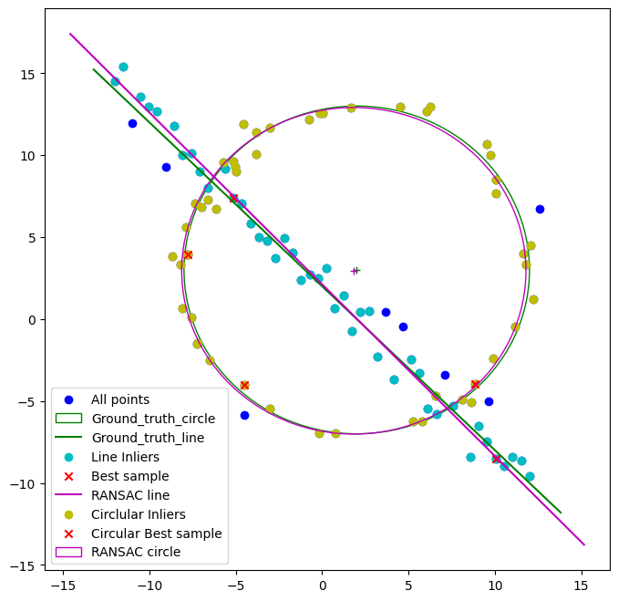

**Question 3**

1. 1.  import cv2 as cv

2. import numpy as np

3. import matplotlib.pyplot as plt

4.

5. clicked_coordinates = []

6. click_count = 0

7.

8. # Mouse callback function

9. def mouse_callback(event, x, y, flags, param):

10. global clicked_coordinates, click_count

11.

12. # If left mouse button is clicked, capture the coordinates and draw a marker

13. if event == cv.EVENT_LBUTTONDOWN:

14. clicked_coordinates.append((x, y))

15. click_count += 1

16. cv.circle(image, (x, y), 5, (0, 0, 255), -1) # Draw a red circle as a marker

17. cv.imshow("Image", image)

18.

19. # If four clicks are captured, stop capturing

20. if click_count == 4:

21. cv.destroyAllWindows()

22.

23.

24. image = cv.imread('images/collage.jpg')

25. cv.imshow("Image", image)

26.

27. cv.setMouseCallback("Image", mouse_callback)

28.

29. cv.waitKey(0)

30.

31. # Output the coordinates

32. print("Clicked Coordinates:")

33. for i, (x, y) in enumerate(clicked_coordinates, start=1):

34. print(f"Point {i}: ({x}, {y})")

35.

36. # display the image with markers in Matplotlib

37. image_rgb = cv.cvtColor(image, cv.COLOR_BGR2RGB)

38. # Set the plot size to 15x15 inches

39. fig, ax = plt.subplots(figsize=(5, 5))

40.

41. ax.imshow(image_rgb)

42. for (x, y) in clicked_coordinates:

43. ax.plot(x, y, 'ro') # Draw a red marker

44.

45. plt.show()

46.

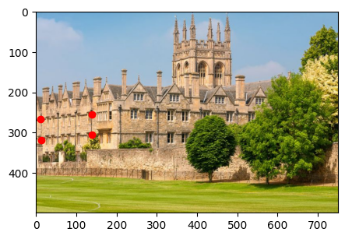

Code for Warping

1. import matplotlib.pyplot as plt

2.

3. img_building = cv.imread('images/collage.jpg')

4. img = cv.cvtColor(img_building, cv.COLOR_BGR2RGB)

5. img_flag = cv.imread('images/flag2.jpg')

6.

7. points_building = np.array(clicked_coordinates, dtype=np.float32)

8.

9. # should be in cliking order

10. point_flag = np.array([[0, 0], [img_flag.shape[1], 0], [img_flag.shape[1], img_flag.shape[0]], [0, img_flag.shape[0]]], dtype=np.float32)

11.

12. # Calculate the homography matrix

13. homography_matrix, _ = cv.findHomography(point_flag, points_building)

14.

15. # Warp the flag image

16. flag_warped = cv.warpPerspective(img_flag, homography_matrix, (img_building.shape[1], img_building.shape[0]))

17. warped_flag=cv.cvtColor(flag_warped, cv.COLOR_BGR2RGB)

18.

19. # Adjust transparency

20. alpha = 0.5

21.

22. # # Create the composite image

23. composite_image = cv.addWeighted(img_building, 1, flag_warped, alpha, 0, dst=img_building)

24. composite=cv.cvtColor(composite_image, cv.COLOR_BGR2RGB)

25.

26. fig, ax = plt.subplots(1, 3, figsize=(15,15))

27.

28. ax[0].imshow(img)

29. ax[0].axis('off')

30. ax[0].legend('Image of the building')

31. ax[1].imshow(warped_flag)

32. ax[1].axis('off')

33. ax[1].legend('Image of the building')

34. ax[2].imshow(composite)

35. ax[2].axis('off')

36. ax[2].legend('Image of the building')

37. plt.show()

38.

**Question 4**